[INSERT COMMUNITY/ORGANIZATION LOGO]

[INSERT COMMUNITY/ORGANIZATION NAME]
Crisis and Emergency Risk Communication Plan

Last Updated: [Insert Date]
Table of Contents
I. Plan Overview 2
Introduction 2
Purpose 3
Scope 3
Planning Assumptions 3
Plan Maintenance and Training 4
II. Roles and Responsibilities 5
Roles and Responsibilities 5
Support from MDPH 6
Additional Local Tasks 7
III. Concept of Operations 8
Internal Communications 8
Public Information 8
Public Information Personnel 9
Public Information Systems 9
Message Development, Approval, and Distribution 10
At-Risk and Hard-to-Reach Populations 11
Managing Misinformation 12
Joint Information System 12
Continuity of Operations 12
Communication During a Technology or Power Disruption 12
Appendix A: Acronyms 14
Appendix B: Contact Information 15
Appendix C: CDC CERC Principles 16
Appendix D: CMIST Functional Needs Framework 17
Appendix E: Message Templates 18
Appendix F: TBD 19

Plan Overview

Introduction
The [Organization Name] Crisis and Emergency Risk Communication (CERC) Plan identifies communication protocols and procedures to be followed in the event of a crisis or emergency with public health consequences. [Note to Community: Decide whether this plan is an Annex to an existing plan (e.g., Emergency Operations Plan, Comprehensive Emergency Management Plan) or whether this will be a standalone plan. If an Annex, reference this here, and then delete red highlighted text.]

The Centers for Disease Control and Prevention (CDC) Public Health Preparedness and Response Capability 4: Emergency Public Information and Warning outlines the responsibility of public health to “develop, coordinate, and disseminate information, alerts, warnings, and notifications to the public and incident management responders.” This capability consists of the ability to perform the following functions:
• Function 1: Activate the emergency public information system
• Function 2: Determine the need for a joint public information system
• Function 3: Establish and participate in information system operations
• Function 4: Establish avenues for public interaction and information exchange
• Function 5: Issue public information, alerts, warnings, and notifications

Crisis and Emergency Risk Communication, as outlined by the CDC, is a term used to cover both the urgency of crisis communication and the need to explain risks and benefits to stakeholders and the public. The CDC emphasizes six principles of effective crisis and risk communication (refer to Appendix C for related infographic).
- Be First: Crises are time sensitive. Communicating information quickly is almost always important. For members of the public, the first source of information often becomes the preferred source.
- Be Right: Accuracy establishes credibility. Information can include what is known, what is not known, and what is being done to fill in the gaps.
- Be Credible: Honesty and truthfulness should not be compromised during crises.
- Express Empathy: Crises create harm, and the suffering should be acknowledged in words. Addressing what people are feeling, and the challenges they face, builds trust and rapport.
- Promote Action: Giving people meaningful things to do calms anxiety, helps restore order, and promotes a restored sense of control.
- Show Respect: Respectful communication is particularly important when people feel vulnerable. Respectful communication promotes cooperation and rapport.

Purpose
This plan provides a framework for communicating with and disseminating information to the public, government agencies, the media, and other stakeholders during a crisis or emergency.

This document is consistent with standards established in the National Incident Management System (NIMS) and is designed to operate under the Incident Command System (ICS). As such, this document is flexible and scalable, and will support CERC functions for a variety of responses.

Scope
This plan is intended to help public information staff and organizational leadership make informed and timely decisions regarding risk communication and public information related to public health. This plan applies to all public health public information needs during events impacting [Organization/Community Name].

Planning Assumptions
The following assumptions describe a typical environment in which the CERC Plan would be activated in whole or in part:
- A crisis, emergency, or disaster is a dynamic situation in which time frames to receive and communicate information are compressed, and misinformation must be addressed.
- The [Organization/Community Name] Emergency Operations Center (EOC) may be activated to support emergency response and recovery operations.
- The Region 4AB Health and Medical Coordinating Coalition (HMCC) Duty Officer is available to support member communities upon request.
- The Massachusetts Department of Public Health (MDPH) may be activated to support major public health emergency responses within the state.
- [Organization/Community Name] designated public information staff will support local risk communication operations as needed.
- Depending on the duration and scope of the incident, community public information staff may be available (on-call, virtually, or in-person) 24-hours a day.
- Depending on the duration and scope of the incident, incident-specific communication methods may be established (e.g., call centers, email addresses, coordinated calls, etc.).
- Social media outlets play an important role in the dissemination of information to the public.
- Risk communication messages and strategies must consider at-risk, isolated, and access and functional needs (AFN) populations.
- Risk communication messages and strategies should use a health equity lens in communication planning, development, and dissemination, to be inclusive, avoid bias and stigmatization, and effectively reach intended audiences. The National Standards for Culturally and Linguistically Appropriate Services (CLAS) should also be referenced.
- Electronic messaging and materials will be developed in accordance with Section 508 of the Rehabilitation Act 1973– Standards for Electronic and Information Technology.
- Region 4AB HMCC may support a regional joint information system as requested by member communities.
- If Communities have completed a Hazard Vulnerability Assessment or Jurisdictional Risk Assessment, you may choose to reference the top hazards here or address somewhere else in this document. Prioritized risks may be also used to develop templated messages (Appendix E).
- Please feel free to add any community specific assumptions or delete this bullet.

Plan Maintenance and Training
This CERC Plan is owned and maintained by [Organization/Community Name]. The plan will be reviewed on an annual basis and is recommended to be evaluated during preparedness exercises. Training and exercises should test the following Centers for Disease Control and Prevention (CDC) Public Health Emergency Preparedness and Response Capabilities: Emergency Public Information and Warning, Information Sharing, and Emergency Operations Coordination.

Message maps and boilerplate messages should be reviewed annually (or more frequently) by PIOs, preparedness staff, and clinical staff to ensure accuracy and adherence to best practices set forth by the CDC and other public health preparedness subject matter experts.

Contact lists should be reviewed quarterly to ensure that key response partners and stakeholders can be contacted easily during emergent situations. Media contact lists should be updated as a part of routine PIO duties (see Appendix B for more information on contact list maintenance).

Roles and Responsibilities

Roles and Responsibilities
Designated roles will fulfill the following responsibilities related to public health crisis and emergency risk communication. All roles and responsibilities are subject to change based on the specific incident needs and current staffing and resources.
Organization/Community/Role | Responsibilities
[Organization/Community]  Board of Health/Health Department | - Serve as the primary local source of public health information during an emergency.  - Utilize MDPH, the HMCC, and/or other resources for clinical messaging to inform local decisions and response.  - Provide public information about local operations and response.  - Perform preparedness, response, and recovery actions related to the primary emergency event, consistent with NIMS and ICS.  - Add additional responsibilities appropriate for your community.
[Organization/Community] Public Information Officer | - Represent and advise the incident commander (if activated) or municipal leadership on all public information matters relating to communication management for the incident, and monitoring and handling media and public inquiries.  - Develop messaging related to the incident for approval by the incident commander or other designated authority.  - Disseminate public information and messaging through established methods.  - Interface with media as needed.  - Coordinating with PIOs from other participating government departments and organizations (if applicable) to manage resources and avoid duplication of efforts.  - Add additional responsibilities appropriate for your community.
[Organization/Community] Spokesperson | - Conduct media interviews, press conferences, and interfacing with outside officials in accordance with approved talking points, message maps, and materials.
Add additional Organizational/Community Departments if desired (e.g., Emergency Management or other Departments with PIOs) | - Add additional responsibilities appropriate for your community.
Region 4AB HMCC | - Collect, validate, and share incident-specific information, tools, or model practices as available that may be used by communities.  - Serve as a conduit between MDPH and communities for unmet information needs.  - Participate in a regional joint information system if initiated by communities.
Massachusetts Department of Public Health | - Support development of incident-specific information, guidance, and/or clinical messaging as detailed in the MDPH EOP (see highlights below) and maintaining situational awareness through disseminating situational awareness statements to health and medical partners.  - Support statewide information sharing needs such as supporting call center(s), developing communications materials for public outreach.  - Establish meeting(s) or communications forums to convene communities for incident-specific information sharing (e.g., Office of Local & Regional Health).  - Maintain emergency communications systems (HHAN, WebEOC) to share updated guidance and relevant information.

Support from MDPH
Local communities and/or other external partners may receive communications from MDPH in order to:
- Provide updates on the status of an event;
- Request information about potential health threats;
- Obtain other information about the event;
- Develop a better understanding of concerns relating to the event;
- Address specific needs relating to the incident; and
- Provide recommendations and request that specific actions be taken.

MDPH may utilize multiple mechanisms to communicate with external partners, including but not limited to:
- HHAN groups;
- Internet conferencing and teleconferencing;
- One-to-one phone contact;
- Group and individual email messages;
- Meetings;
- WebEOC; and
- Listservs
MDPH may also follow established processes to develop messaging for the public. Once information for the public is approved for release, it will be distributed to external partners for dissemination, shared through traditional and social media, and posted to the MDPH or Mass.gov website. If the SEOC is activated, MEMA may establish a Joint Information Center (JIC) to coordinate messaging across multiple state agencies, and the MDPH PIO would participate in the JIC.

Additional Local Tasks
Media Monitoring
The PIO should review media coverage of the incident, provide appropriate updates to leadership, and track any items to be addressed or resolved. Minimum recommended elements to track include:
- Synopsis of daily coverage
- Trends
- Issues/Concerns
- Inaccuracies
- View points
- Fixes or Needs
Public Inquiry
The PIO or designee may be responsible for receiving and tracking public, media, or stakeholder inquiries. Minimum recommended elements to track inquiries include:
- Date/time received
- Name
- Contact information
- Inquiry
- Reply (message, date)

Concept of Operations
This concept of operations addresses the overall communications approach for [Organization Name] during a crisis, public health emergency, or disaster response.

Internal Communications
During a response, it is important to establish clear lines of communication with all staff, contractors, and vendors. Organization uses the following communication methods:
- Email distribution lists
- Calling lists (phone trees)
- Municipal Emergency Notification System
- Add others
Internal communication processes are integral to both emergency operations and continuity of operations. When uninformed, employees can become unofficial spokespersons and can spread misinformation. Therefore, it is important to provide accurate and timely information to all employees throughout the duration of the response. This should include easy access to media releases, public health and safety resources, and other information as necessary. During emergency responses, employees should be reminded to direct all media inquiries to the Lead PIO or JIC if it is activated.

Public Information
During a crisis or emergency, communication to the public may include media releases, website content, talking points for spokespersons, interviews, social media, public service announcements, and advertising. It is important to determine which populations are at greater risk and to use the most appropriate methods to reach these target populations, as well as the general public.
In most cases, messaging should be developed at a sixth-grade reading level. The Lead PIO and/or designated staff will take the lead on developing this type of messaging with input from SMEs as appropriate. Messaging should observe the following guidance:
- Messages are clear, concise, and provide unambiguous action steps;
- Appropriate supporting materials have been identified;
- Messages convey an appropriate sense of urgency or level of priority; and
- Messages are consistent with any state and federal guidance.
In addition to providing accurate and timely information, public information staff must also address misconceptions, misinformation, and rumors. Misinformation in the media should be corrected and addressed during the following news cycle. Add any additional details about local systems/services to monitor social media.

Public Information Personnel
During routine and emergency operations, [Organization Name] has # dedicated Public Information Officer housed in Department Name.
Subject Matter Experts (SMEs)
To ensure the public health message contains appropriate language and guidance, the following subject matter experts may be engaged to support message development:
Topic | Department/Role
Public Health
Clinical Guidance
Environmental Health
Responder Safety
Behavioral Health
Translation/Non-English

Public Information Systems
Multiple communication systems and platforms will be used to communicate with the media, the public, and stakeholder groups. A multifaceted approach will help risk communication messages reach their intended targets. The table below lists various primary and redundant communication systems and platforms along with the target audience(s) reached.
System | Media | Public | Stakeholders | Details
Telephone | X | X | X
Email
Municipal Emergency Notification System
Social Media
List platforms, handles
Conference Calls or web-based platforms
Low tech (e.g., flyers, door to door)
Press conferences, briefings
Call Center
Town halls, community meetings
HHAN |  |  |  | *Reference feature for social media monitoring
WebEOC

In addition to pushing out risk communication messages, it will be crucial to maintain and expand public inquiry capabilities. The primary communication systems used for public inquiry are telephone, email, and social media. Public information personnel can use the following tactics to expand public inquiry capacity:
- Call centers and public inquiry lines (i.e., hotlines) can be established to handle a surge in call volume.
- Response-specific, dedicated email addresses can be created to handle additional questions and comments from the public.
- Social media activities can be increased during a response to allow for more public inquiry and comment.

Message Development, Approval, and Distribution
Public information personnel will follow these steps when developing messaging:
- Information development. In coordination with SMEs, compile or develop clear, appropriate information. Emphasize the six principles of CERC (Appendix C). Additional factors for consideration include:
  - Who is the communicator?
  - What is the time pressure?
  - What is the message's purpose?
- Information validation: In coordination with SMEs, ensure information is current and accurate.
- Identification of vulnerable and at-risk populations. Ensure materials are produced in a manner that is appropriate for each target audience and that messages are distributed to each vulnerable population in the optimal format.
- Information dissemination. Ensure the timely and accurate distribution of public information through appropriate methods and formats.

[Organization Name] follows this process for message development, approval, and distribution.
  - PIO or designated staff develops content.
  - Appropriate subject matter expert (SME) reviews content.
  - EOC Manager or designated authority approves content.
  - PIO distributes content.
Potential message audiences may include:
- Government personnel
- Elected officials
- Local residents
- Higher risk and/or disproportionately impacted populations
- Local health system
- Representatives of local businesses
- Civic groups
- Citizen groups
- Groups of public interest
- Higher education, schools, and/or childcare providers
- Potentially responsible parties
- Other

At-Risk and Hard-to-Reach Populations
[Community Name] recognizes that some individuals and populations may be harder to reach, have access or functional needs, or may be disproportionately impacted by an event.
When developing messages, public information personnel will consider different audiences and their specific needs for message mechanism, message content, and culturally and linguistically appropriate format.
Text-to-speech, text-to-digital, translation services, interpreting services, and other solutions may be used to communicate with access and functional needs (AFN) and hard-to-reach populations. Spokespersons from AFN, at-risk, and lesser English proficiency groups may be engaged to maximize outreach potential to these target audiences. Where possible, electronic messaging will be done in accordance with Section 508 of the Rehabilitation Act – Standards for Electronic and Information Technology. Refer to Appendix D for additional details about developing messages within the CMIST Functional Needs Framework.
Within [Community Name], the following groups have been identified as harder to reach or potentially disproportionately impacted populations. Public information personnel will develop strategies and engage trusted voices to communicate culturally and linguistically appropriate messages and formats.
- Black, Indigenous, and People of Color
- Children
- Homebound individuals
- Immigrant communities
- Individuals experiencing food insecurity
- Individuals with access or functional needs
- Individuals with disabilities
- Individuals and families at lower socio-economic levels
- LGBTQIA+ individuals
- Low/limited access to technology or internet
- Low/limited proficiency in technology
- Non-English Speakers
- Older adults
- Unhoused or unsheltered individuals
- Add based on community risk assessments and other profiles
Trusted Voices
Trust is not easily gained during an emergency. Consistency and current, updated information is key. Utilizing “trusted voices” within the community, typically from community-based organizations, faith-based organizations, or other trusted entities, helps to convey accurate public health messaging, manage misinformation, and combat hesitancy or fear.
Person/Organization | Targeted Audience

Managing Misinformation
Misinformation is information that is false, inaccurate, or misleading according to the best available evidence at the time. Disinformation is false information which is deliberately intended to mislead—intentionally making the misstating facts.
During a public health emergency, it is possible that misinformation or disinformation will be shared. [Community Name] can take the following steps to stop misinformation from spreading:
- Proactively engage with the public on health misinformation.
- Use technology and media platforms to share accurate health information with the public.
- Develop strategies or rules of engagement on when or how to directly to respond to incidents of misinformation.
- Identify common or trending misinformation and provide accurate information.
- Partner with community groups and other local organizations to prevent and address health misinformation.

Joint Information System
A Joint Information System (JIS) is activated anytime two or more public information officers get together to coordinate messaging. The JIS refers to the ICS structure, systems, and equipment used to facilitate communication between PIOs. A Joint Information Center (JIC) is a physical location activated to manage the public information component of a major response.
Describe any local or regional JIS or JIC plans or delete.

Continuity of Operations
During a response, the demand for response-related information may overwhelm the ability of staff to handle regular operations. In this case, state and/or departmental Continuity of Operations Plans (COOP) should be referenced or activated to decide which functions can be ceased and what must continue. The PIO may play an active role in developing internal (departmental) messages to ensure essential functions identified in the COOP are maintained.

Communication During a Technology or Power Disruption
Communication during a technology or power outage will pose extra challenges for public information staff. Depending on the type of disruption, use of low-technology communication methods may be necessary. These include but are not limited to the following:
- Flyers
- Municipal and/or school message boards
- Amateur radios
- Radio public service announcements to reach individuals with battery powered or hand-crank radios
- Wireless Internet connections (e.g., air cards, tablets, cell phones) may still function when landline and cable Internet is out.
- Megaphones (to address crowds)
- 800 MHz radio
- Door-to-door communication with partner agencies.

Appendix A: Acronyms
Acronym | Definition
AFN | Access and Functional Needs
BIDLS | Bureau of Infectious Disease and Laboratory Science (MDPH)
CDC | Centers for Disease Control and Prevention
CERC | Crisis and Emergency Risk Communication
CLAS | Culturally and Linguistically Appropriate Services
CMIST | Communication, medical needs, independence, supervision, transportation.
COOP | Continuity of Operations Plan
HMCC | Health and Medical Coordinating Coalition
EOC | Emergency Operations Center
ICS | Incident Command System
JIC | Joint Information Center
JIS | Joint Information System
MDPH | Massachusetts Department of Public Health
MEMA | Massachusetts Emergency Management Agency
NIMS | National Incident Management System
PHEP | Public Health Emergency Preparedness
PIO | Public Information Officer
SEOC | State Emergency Operations Center (MEMA)
SME | Subject Matter Expert

Appendix B: Contact Information
Communities should complete this table with local contact information and/or reference contact list location(s) on a Community Shared Drive.
Suggested contacts include:
- Internal (Departmental) contact lists: municipal Public Information Officer, key department leads, government officials
- External partner contact lists: see below provided by MDPH and Region 4AB HMCC; add any additional contacts relevant to your community
- Public Information contact lists: local media, newspapers, etc.

Organization | Point of Contact | Phone | Email | Website, Social Media handles
4AB HMCC | 24/7 Duty Officer | 857-239-0662 (pager) |  | https://region4ab.org/
MDPH | 24/7 Duty Officer | 617-339-8351 (pager) |  | https://www.mass.gov/orgs/department-of-public-health
MDPH Bureau of Infectious Disease and Laboratory Science (BIDLS) |  | Urgent calls and infectious disease reporting  (617) 983–6800 |  | https://www.mass.gov/orgs/bureau-of-infectious-disease-and-laboratory-sciences

The 4AB HMCC maintains a 24/7 contact list for communities. Contact the 4AB HMCC (HMCC@challiance.org) or Duty Officer to request current information if needed.

Appendix C: CDC CERC Principles
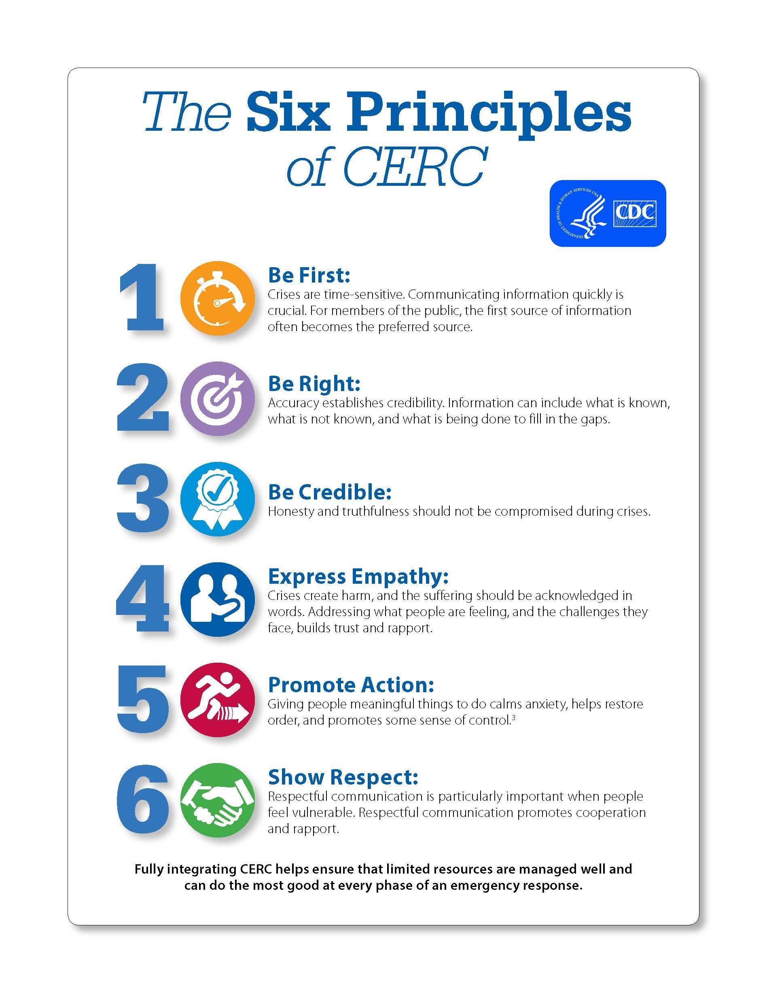

Appendix D: CMIST Functional Needs Framework
The CMIST Functional Needs Framework will inform the development and dissemination of public information. The framework includes five essential functions: communication, medical needs, independence, supervision, transportation.
- Communication: Some people have difficulties receiving and responding to information. People with communication needs may have reduced or no ability to see, hear, or speak; or have limitations understanding or learning. This category also includes people who cannot speak, read, or understand English.
- Medical needs: This category includes people who need assistance with activities of daily living such as grooming, bathing, eating, dressing, or toileting; as well as people who are managing chronic, contagious, or terminal illnesses; and people requiring medications, IV therapy, feeding tubes, dialysis, oxygen, suction, catheters, and ostomies.
- Independence: Some people use medication or assistive devices to function independently on a daily basis, such as mobility aids (wheelchairs, walkers, canes), communication aids (hearing aids, computers), medical equipment (syringes, oxygen), or service animals.
- Supervision: People may require supervision when they experience Alzheimer’s or other forms of dementia; psychiatric conditions such as schizophrenia, severe depression, or chronic and severe mental illness; intellectual or developmental disabilities; or brain injury. Individuals in this category sometimes require a more supervised and protected setting during an emergency.
- Transportation: People who do not drive because of a disability, legal restriction, temporary injury, age, poverty, or lack of access to a vehicle are included in this category.

Appendix E: Message Templates
[PLACEHOLDER]
Communities should review jurisdictional risk assessments and pre-identified audiences to develop message templates and/or checklist of essential elements of information by message mechanism.

Appendix F: TBD
[PLACEHOLDER]

Communities may add any additional community-identified appendices or delete this section

https://www.cdc.gov/healthcommunication/Health_Equity_Lens.html
https://thinkculturalhealth.hhs.gov/clas
Disproportionately impacted populations refers to when a subset of the population, based on characteristics, such as age, race and gender, are unjustifiably experiencing lower outcomes compared to the total population.
National Standards for Culturally and Linguistically Appropriate Services https://thinkculturalhealth.hhs.gov/clas

