
[NAME OF AGENCY]
Crisis and Emergency Risk Communication Plan

Last Updated: [DATE]



This plan was developed in coordination with the Region 4AB Public Health Emergency Preparedness (PHEP) Coalition with funding support by the PHEP Cooperative Agreement from the Centers for Disease Control and Prevention (CDC).
2

Table of Contents
Record of Changes 3
I. Overview 4
A. PURPOSE 5
B. SCOPE 5
C. PLANNING ASSUMPTIONS 5
D. PLAN MAINTENANCE 6
II. Concept of Operations 9
A. ROLES AND RESPONSIBILITIES 9
B. LOCAL PUBLIC INFORMATION OFFICER 11
C. LOCAL PUBLIC INFORMATION SYSTEMS 12
D. SUPPORT FROM MDPH 14
E. TRUSTED VOICES 14
F. AT-RISK AND HARD-TO-REACH POPULATIONS 15
III. Incident Management 16
A. INCIDENT RECOGNITION 16
B. ACTIVATION 16
Internal Communications 17
Public Information 17
Public Inquiry 19
Media Monitoring 19
Managing Misinformation 21
C. INFORMATION SHARING 28
D. EMERGENCY PUBLIC INFORMATION AND WARNING 30
E. JOINT INFORMATION SYSTEM 33
F. CONTINUITY OF OPERATIONS 33
G. RECOVERY CONSIDERATIONS 34
Appendix A: Acronyms 35
Appendix B: Contact List 36
Appendix C: CDC CERC Principles 37
Appendix D: CMIST Functional Needs Framework 38
Appendix E: Call Center Considerations 39
Appendix F: Inquiry Tracking 40
Appendix G: Public Information Officer Checklist 41
Appendix H: Sample Message Guidance 45
Appendix I: Template Instructions 54

Record of Changes
The Massachusetts Region 4AB Public Health Emergency Preparedness (PHEP) Coalition developed and issued this plan as a template for customization and use by local Boards of Health and Health Departments. The Region 4AB PHEP Coalition will periodically review, update, and re-issue the template based on feedback from the Coalition and advances in practice.
The [Agency Name] will review and update the plan annually. Changes to the plan are tracked below by documenting the date, name of the person who changed the document, and a brief description of the change. A new version number should be assigned when local changes are made to the plan (e.g., 1.2, 1.3) and when the Region 4AB PHEP Coalition revises the plan template (e.g. 2.0, 3.0). The record reflects any significant change made to the plan in the prior five years with the most recent change recorded at the top of the record. The revision date (footer) is updated following any change to the plan. When a significant change is made to the plan, the signatories must re-acknowledge their approval and the plan should be redistributed to the agencies listed in the Record of Distribution.
Version | Date | Name | Description
2.1 | 00/00/0000 | Insert Name, Insert Position | Plan customized to document local information and details.
2.0 | 5/1/2026 | Region 4AB PHEP Coalition | Release of plan template 2.0. Revisions made to plan organization, with augmented content related to misinformation and rumor control, public information officer activities, and recovery phase.
1.0 | 4/4/2023 | Region 4AB PHEP Coalition | Release of plan template 1.0.

I. Overview
The [Name of Agency] Crisis and Emergency Risk Communication (CERC) Plan identifies communication protocols and procedures to be followed in the event of a crisis or emergency with public health consequences. [Note to Community: Decide whether this plan is an Annex to an existing plan (e.g., Emergency Operations Plan, Comprehensive Emergency Management Plan) or whether this will be a standalone plan. If an Annex, reference this here, and then delete red highlighted text.]

The Centers for Disease Control and Prevention (CDC) Public Health Preparedness and Response Capability 4: Emergency Public Information and Warning outlines the responsibility of public health to “develop, coordinate, and disseminate information, alerts, warnings, and notifications to the public and incident management responders.” This capability consists of the ability to perform the following functions:
• Function 1: Activate the emergency public information system
• Function 2: Determine the need for a joint public information system
• Function 3: Establish and participate in information system operations
• Function 4: Establish avenues for public interaction and information exchange
• Function 5: Issue public information, alerts, warnings, and notifications

Crisis and Emergency Risk Communication, as outlined by the CDC, is a term used to cover both the urgency of crisis communication and the need to explain risks and benefits to stakeholders and the public. The CDC emphasizes six principles of effective crisis and risk communication (refer to Appendix C for related infographic).

Be First
Crises are time sensitive. Communicating information quickly is almost always important. For members of the public, the first source of information often becomes the preferred source.

Be Right
Accuracy establishes credibility. Information can include what is known, what is not known, and what is being done to fill in the gaps

Be Credible
Honesty and truthfulness should not be compromised during crises.
Express Empathy
Crises create harm, and the suffering should be acknowledged in words. Addressing what people are feeling, and the challenges they face, builds trust and rapport.

Promote Action
Giving people meaningful things to do calms anxiety, helps restore order, and promotes a restored sense of control.

Show Respect
Respectful communication is particularly important when people feel vulnerable. Respectful communication promotes cooperation and rapport.

A. PURPOSE
This plan provides a framework for communicating with and disseminating information to the public, government agencies, the media, and other stakeholders during a crisis or emergency.

This document is consistent with standards established in the National Incident Management System (NIMS) and is designed to operate under the Incident Command System (ICS). As such, this document is flexible and scalable and will support CERC functions for a variety of responses.

B. SCOPE
This plan is intended to help public information staff and organizational leadership make informed and timely decisions regarding risk communication and public information related to public health. This plan applies to all public health public information needs during events impacting [Name of Agency].

C. PLANNING ASSUMPTIONS

The following assumptions describe a typical environment in which the CERC Plan would be activated in whole or in part:
- A crisis, emergency, or disaster is a dynamic situation in which time frames to receive and communicate information are compressed, and misinformation must be addressed.
- The [Name of Agency] Emergency Operations Center (EOC) and/or Department Operations Center (DOC) may be activated to support emergency response and recovery operations.
- The Region 4AB Health and Medical Coordinating Coalition (HMCC) Duty Officer is available to support member communities upon request.
- The Massachusetts Department of Public Health (MDPH) may be activated to support major public health emergency responses within the state.
- [Name of Agency] designated public information staff will support local risk communication operations as needed.
- Depending on the duration and scope of the incident, community public information staff may be available (on-call, virtually, or in-person) 24-hours a day.
- Depending on the duration and scope of the incident, incident-specific communication methods may be established (e.g., call centers, email addresses, coordinated calls, etc.).
- Social media outlets play an important role in the dissemination of information to the public.
- Risk communication messages and strategies must consider at-risk, isolated, and/or access and functional needs (AFN) populations.
- Risk communication messages and strategies should use a health equity lens in communication planning, development, and dissemination, to be inclusive, avoid bias and stigmatization, and effectively reach intended audiences. The National Standards for Culturally and Linguistically Appropriate Services (CLAS) should also be referenced.
- Electronic messaging and materials should be developed in accordance with Section 508 of the Rehabilitation Act 1973– Standards for Electronic and Information Technology.
- The Region 4AB HMCC may support a regional joint information system as requested by member communities.
- If Communities have completed a Hazard Vulnerability Assessment or Jurisdictional Risk Assessment, you may choose to reference the top hazards here or address somewhere else in this document. Prioritized risks may be also used to develop templated messages (Appendix E).
- Please feel free to add any community specific assumptions or delete this bullet.

D. PLAN MAINTENANCE
[Name of Agency, Department] coordinates the development and maintenance of this plan. The plan will be updated when laws, policies, operations, or staffing change and after exercises or real events to incorporate lessons learned. All updates will be tracked in the plan’s Record of Changes. Each Division/Agency, staff member, and stakeholder with responsibilities assigned in the framework shall review the plan annually.
Training and exercises should also evaluate this plan, testing the following Centers for Disease Control and Prevention (CDC) Public Health Emergency Preparedness and Response Capabilities: Emergency Public Information and Warning, Information Sharing, and Emergency Operations Coordination. Elements for evaluation may include time to develop messaging, time to notify staff or the public of an incident, translation capabilities, etc.
Contact lists should be reviewed quarterly to ensure that key response partners and stakeholders can be contacted easily during emergent situations. Media contact lists should be updated as a part of routine PIO duties (see Appendix B for more information on contact list maintenance).

[Name of Agency, Department] coordinates the development and maintenance of this plan. The plan will be updated when laws, policies, operations, or staffing change and after exercises or real events to incorporate lessons learned. All updates will be tracked in the plan’s Record of Changes. Each Division/Agency, staff member, and stakeholder with responsibilities assigned in this plan shall review the plan annually.

Training, Exercises, and Improvement Planning
Training and exercises will be used to evaluate this plan using a Homeland Security Exercise and Evaluation Program (HSEEP)-aligned approach. Training and exercises should test the following Centers for Disease Control and Prevention (CDC) Public Health Emergency Preparedness and Response Capabilities: Emergency Public Information and Warning, Information Sharing, and Emergency Operations Coordination.

Minimum recommended training activities include:
- Annual role-based orientation for staff with CERC responsibilities (PIO, back-up PIO, spokesperson(s), leadership approver, monitoring/listening lead, and inquiry/call center support).
- Practice using key tools and workflows in this plan, including message development and approval, media inquiry response, media monitoring/listening, and rumor management.
- A just-in-time refresher at the start of any activation (who approves messages, where updates will be posted, and how rumors will be logged and addressed).

Minimum recommended exercise activities include:
- At least one annual exercise activity (workshop/tabletop or integrated into another exercise) that includes:
  - Communication surveillance/media monitoring;
  - Media relations (responding to a media inquiry using approved key messages);
  - Digital strategies (drafting website and social media updates); and
  - Managing misinformation (logging and triaging a rumor and documenting an action decision).
- At least one short drill to practice time-sensitive tasks such as drafting and approving a first public message (holding statement), notifying staff, and initiating translation/accessibility support when needed.

Elements for evaluation may include:
- Time to develop and approve messaging (including a first “holding statement”);
- Time to notify staff and/or the public of an incident;
- Time to respond to media inquiries with approved key messages;
- Time to produce a first monitoring/listening summary and update messages based on findings;
- Time to log and triage rumors and document a response decision; and
- Translation and accessibility capabilities (including the process to request and release accessible formats).

After exercises and real events that activate this plan, [Name of Agency, Department] should document lessons learned and track corrective actions. This may include:
- A hotwash (immediate debrief) to capture strengths and gaps;
- An After Action Report/Improvement Plan (AAR/IP) or brief improvement summary; and
- Assigned corrective actions with an owner and due date, tracked until completed and validated (plan update, training, or retest).

Contact lists should be reviewed quarterly to ensure that key response partners and stakeholders can be contacted easily during an emergency. Media contact lists should be updated as a part of routine PIO duties (see Appendix B for more information on contact list maintenance).

II. Concept of Operations

A. ROLES AND RESPONSIBILITIES

Designated roles will fulfill the following responsibilities related to public health crisis and emergency risk communication. All roles and responsibilities are subject to change based on the specific incident needs and current staffing and resources.

Agency/Role | Responsibilities
[Agency/Community]  Board of Health/Health Department | - Serve as the primary local source of public health information during an emergency.  - Utilize MDPH, the HMCC, and/or other resources for clinical messaging to inform local decisions and response.  - Provide public information about local operations and response.  - Perform preparedness, response, and recovery actions related to the primary emergency event, consistent with NIMS and ICS.  - Add additional responsibilities appropriate for your community.
[Agency/Community] Public Information Officer | - Connect with communities and build partnerships; get to know your audience(s).  - Represent and advise the incident commander (if activated) or municipal leadership on all public information matters relating to communication management for the incident, and monitoring and handling media and public inquiries.  - Develop messaging related to the incident for approval by the incident commander or other designated authority.  - Disseminate public information and internal communications through established methods.  - Interface with media as needed.  - Coordinating with PIOs from other participating government departments and organizations (if applicable) to manage resources and avoid duplication of efforts.  - Address misinformation/disinformation based on established protocols.  - Add additional responsibilities appropriate for your community.
[Agency/Community] Spokesperson | - Assigned by the incident commander or designee.  - Conduct media interviews and/or press conferences, and interface with outside officials in accordance with approved talking points, message maps, and materials.
Add additional Agency/Community Departments if desired (e.g., Emergency Management or other Departments with PIOs) | - Add additional responsibilities appropriate for your community.
Region 4AB HMCC | - Collect, validate, and share incident-specific information, tools, or model practices as available that may be used by communities.  - Serve as a conduit between MDPH and communities for unmet information needs.  - Participate in a regional joint information system if initiated by communities.
Massachusetts Department of Public Health (MDPH) | - Support development of incident-specific information, guidance, and/or clinical messaging as detailed in the MDPH EOP (see highlights below) and maintaining situational awareness through disseminating situational awareness statements to health and medical partners.  - Support statewide information sharing needs such as supporting call center(s), developing communications materials for public outreach.  - Establish meeting(s) or communications forums to convene communities for incident-specific information sharing (e.g., Office of Local & Regional Health).  - Maintain emergency communications systems (HHAN, WebEOC) to share updated guidance and relevant information.
Hospital/Healthcare Partners | - Provide current contact information to LBOH.  - Share information about situation status, continuity of operations, and other incident updates.  - Participate in Joint Information System as invited/relevant.

B. LOCAL PUBLIC INFORMATION OFFICER
Public information entails the processes and systems that enable effective communications with various target audiences. Before, during, and after an incident, coordinated and timely communication to the public is critical.
The right message,
to the right people,
at the right time.
Effective communication can save lives and property and can promote credibility and public trust. PIOs are key members of Incident Command System (ICS) and Emergency Operations Center (EOC) organizations, and they work closely with officials who are part of Multiagency Coordination Groups (MAC Groups).
PIOs advise the Incident Commander (IC), Unified Command, and/or EOC Director on public information relating to incident management. PIOs also handle the following:
- Inquiries from the media, the public, and elected officials
- Public information and warnings
- Rumor monitoring and response
- Media relations
- Digital communications
- Multimedia content
- Other functions necessary to gather, verify, coordinate, and disseminate accurate, accessible, and timely information (information on public health, safety, and protecting private property is particularly important)
- Monitoring media and other sources of public information and transmitting relevant information to appropriate personnel at the incident site, in an EOC, or in a MAC Group
Refer to Appendix G for a Public Information Officer Position Checklist.
Public Information Officer Personnel
During routine and emergency operations, [Name of Agency] has # dedicated Public Information Officer housed in Department Name.
Subject Matter Experts (SMEs)
To ensure the public health message contains appropriate language and guidance, the following subject matter experts may be engaged to support message development:
Topic | Department/Role
Public Health
Clinical Guidance
Environmental Health
Responder Safety
Behavioral Health
Translation/Non-English

C. LOCAL PUBLIC INFORMATION SYSTEMS
Multiple communication systems and platforms will be used to communicate with the media, the public, and stakeholder groups. A multifaceted approach will help risk communication messages reach their intended targets. The table below lists various primary and redundant communication systems and platforms along with the target audience(s) reached.
System | Media | Public | Stakeholders | Details
Telephone | X | X | X
Email
Municipal Emergency Notification System
Social Media
List platforms, handles
Conference Calls or web-based platforms
Low tech (e.g., flyers, door to door)
Press conferences, briefings
Call Center
Town halls, community meetings
HHAN
WebEOC
In addition to pushing out risk communication messages, it will be crucial to maintain and expand public inquiry capabilities. The primary communication systems used for public inquiry are telephone, email, and social media. Public information personnel can use the following tactics to expand public inquiry capacity:
- Call centers and public inquiry lines (i.e., hotlines) can be established to handle a surge in call volume.
- Response-specific, dedicated email addresses can be created to handle additional questions and comments from the public.
- Social media activities can be increased during a response to allow for more public inquiry and comment.

D. SUPPORT FROM MDPH
Local communities and/or other external partners may receive communications from MDPH in order to:
- Provide updates on the status of an event;
- Request information about potential health threats;
- Obtain other information about the event;
- Develop a better understanding of concerns relating to the event;
- Address specific needs relating to the incident; and
- Provide recommendations and request that specific actions be taken.

MDPH may utilize multiple mechanisms to communicate with external partners, including but not limited to:
- HHAN groups (along with spreadsheet alerting);
- MAVEN;
- Virtual meeting platforms;
- One-to-one phone contact;
- Group and individual email messages;
- Meetings; and
- WebEOC;
MDPH may also follow established processes to develop messaging for the public. Once information for the public is approved for release, it will be distributed to external partners for dissemination, shared through traditional and social media, and posted to the MDPH or Mass.gov website. If the SEOC is activated, MEMA may establish a Joint Information Center (JIC) to coordinate messaging across multiple state agencies, and the MDPH PIO would participate in the JIC.

E. TRUSTED VOICES
Trust is not easily gained during an emergency. Consistency and current, updated information is key. Utilizing “trusted voices” within the community, typically from community-based organizations, faith-based organizations, or other trusted entities, helps to convey accurate public health messaging, manage misinformation, and combat hesitancy or fear.
Person/Organization | Targeted Audience

F. AT-RISK AND HARD-TO-REACH POPULATIONS
[Name of Agency] recognizes that some individuals and populations may be harder to reach, have access or functional needs, or may be disproportionately impacted by an event.
When developing messages, public information personnel will consider different audiences and their specific needs for message mechanism, message content, and culturally and linguistically appropriate format.
Text-to-speech, text-to-digital, translation services, interpreting services, and other solutions may be used to communicate with access and functional needs (AFN) and hard-to-reach populations. Spokespersons from AFN, at-risk, and low English proficiency groups may be engaged to maximize outreach potential to these target audiences. Where possible, electronic messaging will be done in accordance with Section 508 of the Rehabilitation Act – Standards for Electronic and Information Technology. Refer to Appendix D for additional details about developing messages within the CMIST Functional Needs Framework.
Within [Community Name], the following groups have been identified as harder to reach or potentially disproportionately impacted populations. Public information personnel will develop strategies and engage trusted voices to communicate culturally and linguistically appropriate messages and formats.
- Black, Indigenous, and People of Color
- Children
- Homebound individuals
- Immigrant communities
- Individuals experiencing food insecurity
- Individuals with access or functional needs
- Individuals with disabilities
- Individuals and families at lower socio-economic levels
- LGBTQIA+ individuals
- Low/limited access to technology or internet
- Low/limited proficiency in technology
- Non-English Speakers
- Older adults
- Unhoused or unsheltered individuals
- Add based on community risk assessments and other profiles

III. Incident Management

A. INCIDENT RECOGNITION

When an incident occurs or is identified through epidemiological analysis, [Name of Agency] will:
- Assess the situation and potential public health impacts;
- Issue public warnings or guidance, if needed;
- Determine whether to activate a Department Operations Center (DOC);
- Alert DOC staff and notify internal and external partners;
- Conduct DOC operations:
- Plan for recovery and deactivation/demobilization.
- Coordinate with local EMD and municipal officials.
Crisis and emergency risk communications may occur before, during, and after an incident and may occur regardless of a formal EOC/DOC activation.

B. ACTIVATION
When notified of an incident or when an incident is detected, the [Agency position of authority] will conduct an incident assessment, set early health and medical objectives, determine whether to activate the DOC, and establish the initial course of action. Refer to the [Name of Agency] Public Health Emergency Response Framework for additional details about the organizational response structure and procedures.
A Public Information Officer may be activated to coordinate internal communications and public information during an incident.
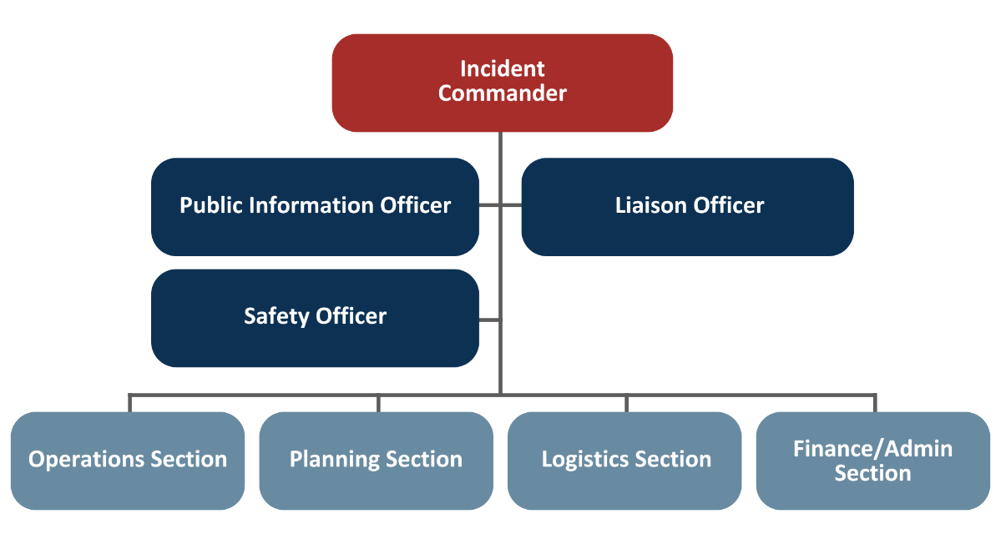

Internal Communications
During a response, it is important to establish clear lines of communication with all staff, contractors, and vendors. [Name of Agency] uses the following communication methods:
- Email distribution lists
- Calling lists (phone trees)
- Municipal Emergency Notification System
- Add others
Internal communication processes are integral to both emergency operations and continuity of operations. When uninformed, employees can become unofficial spokespersons and can spread misinformation. Therefore, it is important to provide accurate and timely information to all employees throughout the duration of the response. This should include easy access to media releases, public health and safety resources, and other information as necessary. During emergency responses, employees should be reminded to direct all media inquiries to the Lead PIO or JIC if it is activated.

Public Information
During a crisis or emergency, communication to the public may include media releases, website content, talking points for spokespersons, interviews, social media, public service announcements, and advertising. It is important to determine which populations are at greater risk and to use the most appropriate methods to reach these target populations, as well as the general public.
In most cases, messaging should be developed at a sixth-grade reading level. The Lead PIO and/or designated staff will take the lead on developing this type of messaging with input from SMEs as appropriate. Messaging should observe the following guidance:
- Messages are clear, concise, and provide unambiguous action steps;
- Appropriate supporting materials have been identified;
- Messages convey an appropriate sense of urgency or level of priority; and
- Messages are consistent with any state and federal guidance.
Additional guidance on public information and message development is provided below in sub-section D.
Some pre-scripted messages for top identified hazards are provided in Appendix G.

Public Inquiry
The PIO or designee may be responsible for receiving and tracking public, media, or stakeholder inquiries. Minimum recommended elements to track inquiries include:
- Date/time received
- Name
- Contact information
- Inquiry
- Reply (message, date)
A sample table to track incoming messages is provided in Appendix F.

Media Monitoring
Establishing routine social media monitoring activities is key to detect early signals of rumors before they become “rumor trending events” and attract significant social attention. Search engines are one of the first places users go to when they have questions or concerns around a certain issue. Oftentimes, searches that are trending on engines can signal the presence of misinformation around a certain issue: users see something on social media, and they go on Google to verify whether what they read is true or find more information about it.
The PIO should review media coverage of the incident, provide appropriate updates to leadership, and track any items to be addressed or resolved. Minimum recommended elements to track include:
- Synopsis of daily coverage
- Trends
- Issues/Concerns
- Inaccuracies
- View points
- Fixes or Needs
Routine media monitoring helps to detect early signs of rumors, confusion, and information gaps. It also helps the PIO improve messages and correct errors quickly. Search engines are often one of the first places people go when they have questions. Trending searches can signal that people are seeing possible misinformation and trying to verify what is true.

Roles and responsibilities
- The PIO is responsible for media monitoring or may assign this task to a Monitoring/Listening Lead.
- The PIO should identify a back‑up person who can monitor media when the PIO is unavailable.
- When the EOC/DOC is activated, the Monitoring/Listening Lead provides regular updates to leadership and the incident management team.

What to monitor (recommended sources)
During routine operations and during an incident, monitor sources such as:
- Local and regional news coverage (TV, radio, online, print)
- Social media and online sources where residents get information (e.g., official accounts, community pages/groups, local partners)
- Search trends and common questions (e.g., trending searches related to the incident)
- Public questions and inquiries received by the Health Department (see Appendix F: Inquiry Tracking)
- Feedback and questions from community partners (schools, long‑term care, faith‑based groups, cultural organizations, etc.)

When and how often to monitor (cadence)
- Routine (steady state): Monitor key sources at least weekly and after major posts or announcements to identify questions and correct errors early.
- During an incident: Begin monitoring as soon as the PIO is activated. Provide the first monitoring update within 3 hours and then at least every 6 hours during the first day or until the situation stabilizes. Adjust based on staffing and incident needs.

What to track (minimum recommended elements)
The PIO or Monitoring/Listening Lead should review media coverage and track items to be addressed or resolved. At a minimum, track:
- Synopsis of daily coverage
- Trends
- Issues/concerns
- Inaccuracies
- Viewpoints
- Fixes or needs

Outputs (what to produce and share)
- Media Monitoring Log: Document what was observed, what needs follow‑up, and recommended actions.
- Listening Snapshot (recommended): A short summary shared with leadership and response staff that includes:
  - Top public questions/concerns
  - Rumors or misinformation of concern
  - Information gaps (what people are missing or misunderstanding)
  - Recommended message updates and best channels to use

How monitoring connects to messaging and rumor management
- Use monitoring findings to update messages, FAQs, website content, and social media content.
- If monitoring identifies misinformation or rumors, document the issue and coordinate response actions using the plan’s Managing Misinformation procedures.
Local monitoring tools and access (customize)
Add any local systems/services used to support monitoring (examples: platform notifications, keyword alerts, shared monitoring inbox, partner “feedback loop,” etc.).

Routine Monitoring Sources (customize)
Add sources that should be checked regularly for routine, steady state monitoring and include the website or information needed to access the source.

Source | Website | Notes
Boston Globe | https://www.bostonglobe.com/

Managing Misinformation
In addition to providing accurate and timely information, public information staff must also address misconceptions, misinformation, and rumors. Misinformation is information that is false, inaccurate, or misleading according to the best available evidence at the time. Disinformation is false information which is deliberately intended to mislead—intentionally making the misstating facts.
Adopting a proactive approach to communication is a key component of effective rumor management. Strive to provide content that is up to date and consistent, strategically located/easy to access, and user centered.
During a public health emergency, it is possible that misinformation or disinformation will be shared. [Community Name] can take the following steps to stop misinformation from spreading:
- Proactively engage with the public on health misinformation.
- Use technology and media platforms to share accurate health information with the public.
- Develop strategies or rules of engagement on when or how to directly to respond to incidents of misinformation.
- Identify common or trending misinformation and provide accurate information.
- Partner with community groups and other local organizations to prevent and address health misinformation.
- Address and correct misinformation in the media as soon as possible, no later than the following news cycle.
Direct engagement with rumors can be warranted depending on the type of content being spread and its potential impact on outcomes such as adoption of preventive behaviors and access to services. There are two key decisions to be made around direct engagement with rumors: 1) does the rumor warrant de-bunking? 2) if so, what are key guidelines for engagement? There are risks to directly responding to content, such as alienating audiences or potentially reinforcing/amplifying the wrong information by giving it a platform.
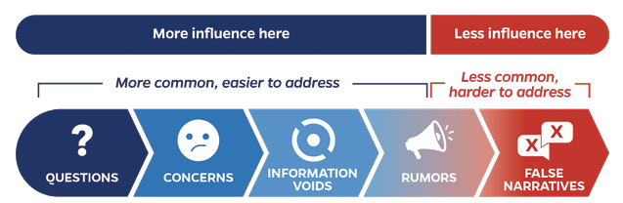

Consider the following when deciding whether to engage with a piece of mis/disinformation:
- Spread - how widespread is the rumor?
- Content - is the topic related to key programs or activities?
- Risk Level - what risks are associated with the rumor? Could it cause harm or risky behavior, stop people from accessing services, stigmatize certain groups, or pose a reputational risk?
If the decision is made to engage, consider the following guidelines. Simply issuing a correction is often not effective to counter misinformation.
- Focus on the facts rather than on the rumor. Do not reinforce the misinformation and make very clear to the audience what the facts are. Consider stating the fact directly in the title, so as to avoid any confusion. When possible, avoid negative sentences to reduce the likelihood of misunderstanding.
- Expose the misinformation techniques. It is important to provide a line of reasoning why the previous information was incorrect, showing the technique that was used to promulgate misinformation.
- Consider how to convey the message, including who should be offering the correction and how to frame the message. Identifying credible individuals and partners that are trusted by a certain audience can help convey messages and clear doubts. A source’s perceived trustworthiness is often more determinant than their expertise in changing users’ misperceptions.
- Make the content visually appealing. Visuals are typically more effective to attract attention and help individuals process the information.
In addition to sharing accurate and timely information, public information staff must also identify and address rumors and false information. The goal is to reduce harm, prevent confusion, protect access to services, and maintain trust by quickly sharing clear facts and correcting false information when needed.

Key Terms
- Rumor: Information that has not been confirmed.
- Misinformation: False or misleading information shared by mistake.
- Disinformation: False information shared on purpose to mislead.

Roles and Responsibilities
At minimum, identify the following:
- PIO (or designee): Manages rumor intake, tracking, coordination, and public corrections.
- Subject matter expert(s) (SME[s]): Verify technical accuracy and provide recommended facts/actions.
- Approving authority: [Health Director / Incident Commander / EOC Manager / other designated authority] approves public corrections (per local policy).
- Partners/trusted messengers: Share coordinated corrections and help fill information gaps.

Key Actions
[Community Name] will use these actions to reduce rumors before and during an incident:
- Share regular updates that are easy to find (website, social media, phone line, partners).
- Use plain language and clear action steps.
- Coordinate messages with partners and leadership so information is consistent.
- Monitor news, social media, and public questions (see “Media Monitoring” and “Public Inquiry”).
- Correct errors quickly when needed (preferably before the next news cycle).

Rumor Management Workflow
When a rumor or false claim is identified, [Community Name] will follow these steps:
- Detect. Monitor news, social media, inquiries, and partner feedback. Capture the rumor content (link, screenshot, headline, or quote) and note where it appears. Required Output: Rumor captured (link/screenshot)
- Log. Enter the rumor into the Rumor Log. Assign an owner (usually the PIO or designee) and a due time for review. (See Appendix X: Rumor Management Tools.) Required Output: Rumor Log entry
- Verify. Confirm facts with Subject Matter Experts (SMEs) and official sources (e.g., MDPH/CDC guidance). Document what is known and unknown. Required Output: Verification note
- Triage. Rate the rumor based on spread, harm, service impact, and trust impact. Set a risk level (Low/Medium/High) (See Rumor Triage Rubric.) Required Output: Risk rating
- Decide. Choose one action (Monitor/Clarify/Correct/Escalate) and document why. Not every rumor needs a public response, and responding can sometimes amplify the false claim. Required Output: Decision recorded
- Draft. If correcting, draft a short fact-based message with clear actions. Avoid repeating the rumor more than necessary. Use the Truth Sandwich and other tools in Appendix H when helpful. Required Output: Draft correction message
- Approve. Route for SME review and approval per local policy. Required Output: Approve message
- Share. Post/share on the channels where the rumor is spreading. Coordinate with partners/trusted messengers when helpful. Ensure partner agencies are aligned. Update FAQ/website if needed. Required Output: Released products; partner notification
- Monitor. Watch for repeats, questions, and confusion. Update messages if needed. Required Output: Monitoring note; updated message
- Close & document. Close the rumor entry when resolved. Save key products for after-action review. Required Output: Closed Rumor Log entry

Escalate and Coordinate (when needed)
Notify and coordinate with regional/state partners when:
- The rumor is high risk (unsafe behavior, safety impacts, or access-to-care impacts).
- The rumor affects multiple communities or shared services.
- The rumor conflicts with, or requires clarification of, MDPH clinical guidance.

Documentation
Maintain the Rumor Log and keep copies of key messages and decisions. Include rumor response actions in after-action notes and improvement planning.

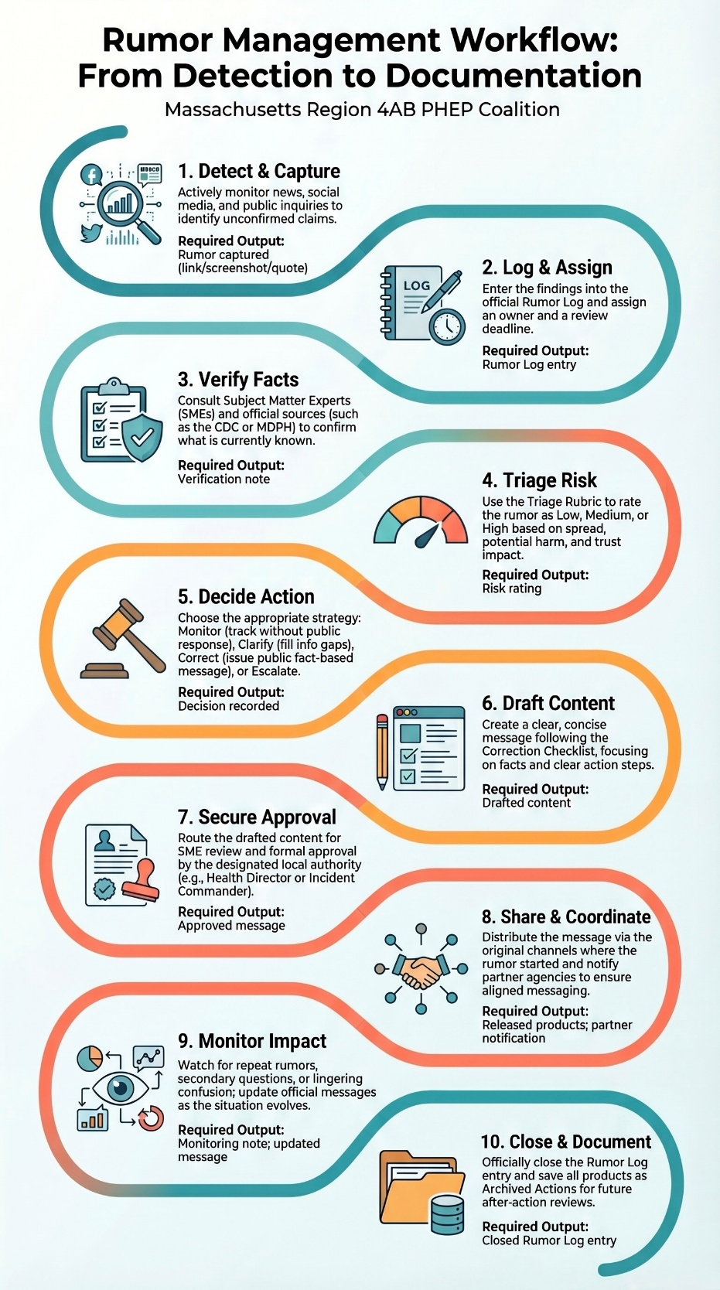

Rumor Triage Rubric
Use this rubric to set priority and choose an action. Rate each category as Low, Medium, or High.
Spread
- Low: Limited audience; single post/outlet; not being repeated.
- Medium: Repeated by multiple people/outlets; growing.
- High: Widely shared; trending; showing up across platforms or communities.

Harm
- Low: Confusion only; no unsafe actions expected.
- Medium: May reduce protective actions or increase calls/complaints.
- High: Could lead to unsafe behavior, delayed care, or urgent safety risk.

Service impact
- Low: No impact to services.
- Medium: May affect turnout/attendance/behavior.
- High: Likely to keep people from accessing services or disrupt operations.

Trust impact
- Low: Minor credibility issues.
- Medium: Undermines confidence in the response.
- High: Fuels stigma, targets groups, or significantly erodes trust.

Suggested action
- Low overall risk: Monitor and fill information gaps (for example, a FAQ update).
- Medium overall risk: Clarify quickly; coordinate with partners; consider a public correction.
- High overall risk: Correct quickly; coordinate widely; escalate if clinical guidance is involved or if the rumor is regional.

Time expectations
- High-risk rumors: verify and decide within 1 hour, then correct/clarify as soon as approved.
- Lower-risk rumors: verify and decide within the same operational period.

Response Options Menu
Choose one option and document why:
- Monitor: Track it. Do not respond publicly right now.
- Clarify: Add a FAQ, website update, or “what we know now” post to fill the gap.
- Correct: Issue a public correction that focuses on facts and actions.
- Escalate: Coordinate with Region 4AB/HMCC and/or MDPH for unified messaging.

Correction Checklist
Before releasing a correction, confirm:
- The message leads with the fact and includes clear action steps.
- The message avoids repeating the false claim more than necessary.
- The message uses plain language and a respectful tone.
- The message names where to find updates (website/phone line).
- The message is shared where the rumor is spreading (and through trusted messengers when helpful).
- The response is logged (Rumor Log and message approval/documentation).
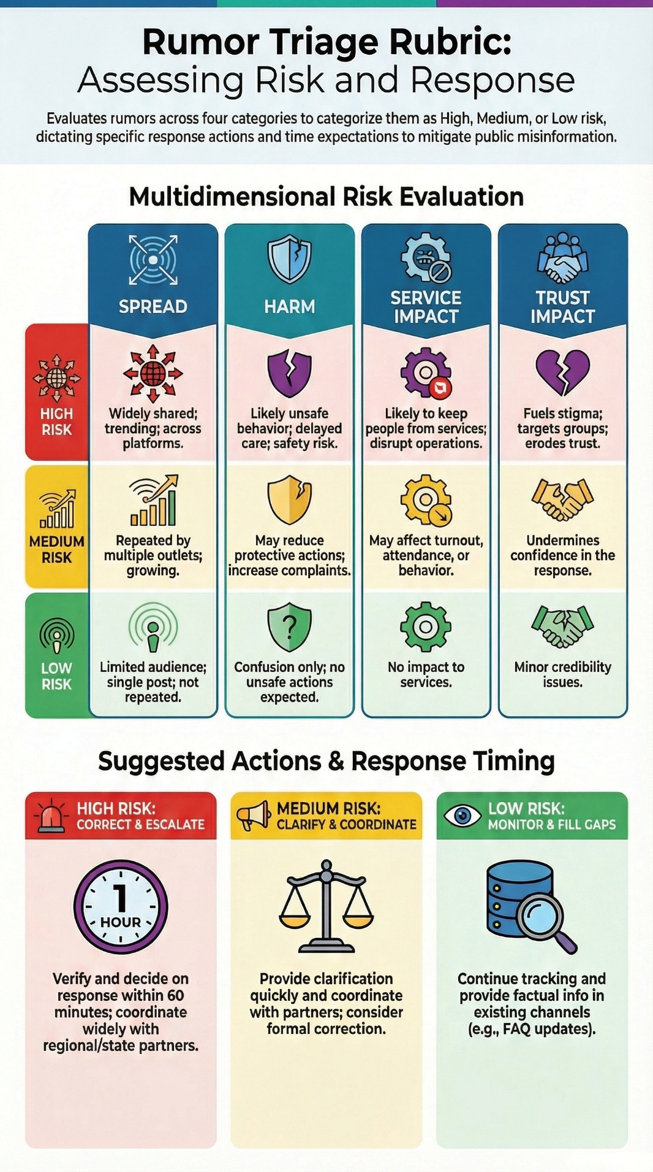

C. INFORMATION SHARING
Clear and timely information and situational awareness data ensures a common operating picture. In addition to CERC principles, the PIO or other designated role may be responsible for information sharing during an incident. The following graphics demonstrate how [Name of Agency] shares and manages information.
How [Name of Agency] Manages Information
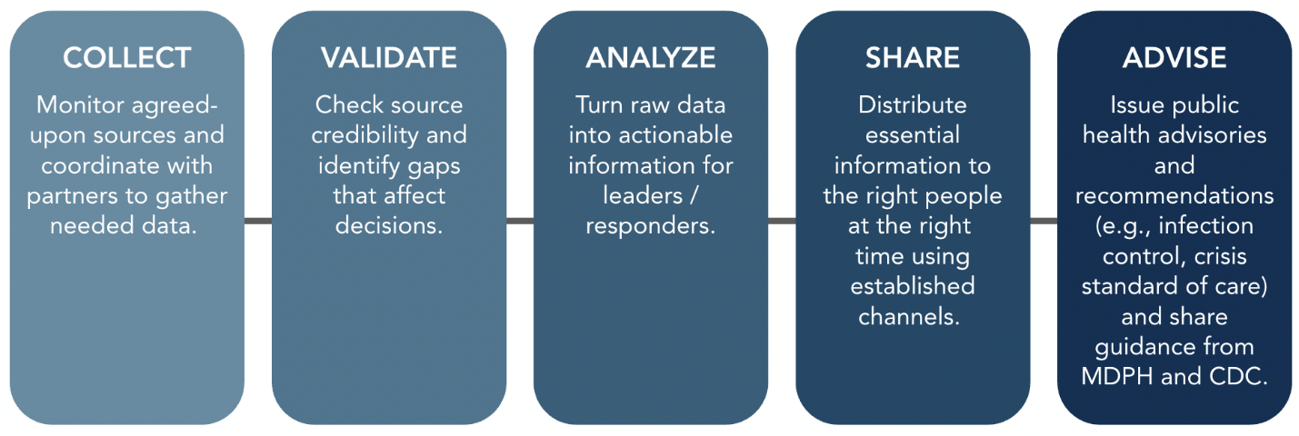
Common Information Sources
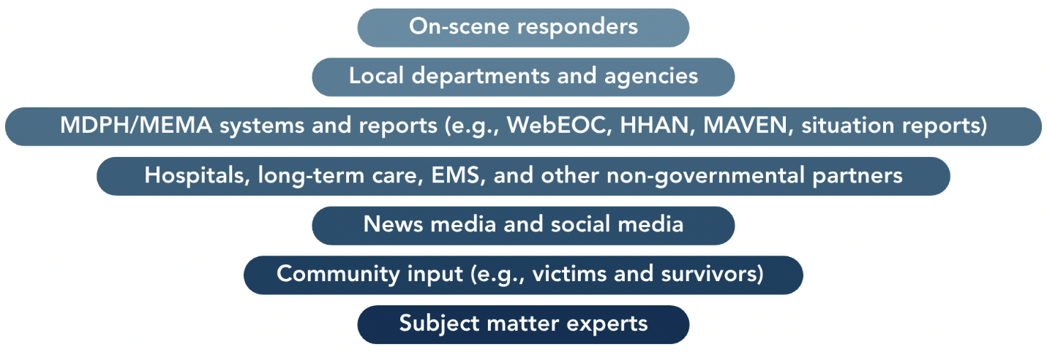

Information Sharing Tools

Telephone and email
[Name of Agency] website, dashboards, and social media (if applicable)
Virtual meeting platforms
MDPH systems (WebEOC, HHAN, MAVEN)
Additional jurisdiction-based tools
Information Systems and Their Use

Tool | What it’s for | Key Notes
Web Emergency Operations Center (WebEOC) | Health and medical incident management; maintaining situational awareness and a common operating picture. | MDPH and MEMA run separate WebEOC systems. MDPH WebEOC is not monitored 24/7. Local Boards of Health (LBOH) use it to share information with partners and document actions for accountability and potential reimbursement.
Health and Homeland Alert Network (HHAN) | Secure alerts and information sharing with public health and healthcare partners (e.g., disease updates, clinical guidance, standing orders). | Used by MDPH and all 351 municipalities. Designed for timely, targeted alerts and protected communications.
Massachusetts Virtual Epidemiologic Network (MAVEN) | Statewide disease surveillance and case management; captures lab, clinical, and public health data. | Supports electronic lab reporting (ELR) and sends automatic 24/7/365 notifications to state and local officials for events needing attention. By law, LBOH, providers, and labs must report notifiable diseases in MAVEN.

D. EMERGENCY PUBLIC INFORMATION AND WARNING
[Name of Agency] develops, coordinates, and disseminates information, alerts, warnings, and notifications during any incident with public health impacts.
What we communicate | Messages should:  - Use plain language (about a 6th-grade reading level).  - Be clear, concise, and actionable.  - Match the urgency of the situation.  - Align with state and federal guidance.  - Include supporting materials (FAQs, graphics, translations) as needed.
Who speaks | - The Public Information Officer (PIO) or designee is the only person authorized to speak to the media.  - The PIO coordinates message development with subject matter experts.
How we reach people | Choose the best channels for the audience and access needs:  - News releases and media briefings  - Website updates and dashboards  - Social media posts  - Public service announcements and paid ads  - Talking points for officials and call centers  - Multilingual and accessible formats (e.g., large print, ASL, captioning)
Reaching at-risk groups | - Identify populations at greater risk and tailor messages and delivery methods (e.g., language access, trusted messengers, community partners).
Addressing misinformation | - Monitor media and social media for rumors and errors.  - Correct misinformation quickly - preferably before the next news cycle.  - Share consistent updates and point to official sources (MDPH, CDC).

Message Development, Approval, and Distribution
Public information staff use the steps below to create clear, accurate, and timely messages.
Develop the message | - Work with subject matter experts (SMEs) to draft plain language content with clear actions.  - Apply CERC principles (see Appendix C): be first, be right, be credible, express empathy, promote action, show respect.  - Consider:  - Who is speaking (spokesperson)  - How fast the message is needed (time pressure)  - Why you’re communicating (purpose and desired action)
Validate the information | - Confirm facts, numbers, sources, and dates with SMEs.  - Align with MDPH/CDC guidance and local policies.
Tailor for the audience | - Identify at-risk and vulnerable groups.  - Ensure materials are produced in a manner that is appropriate for each target audience and that messages are distributed to each population in the optimal format.  - Provide translation and accessible formats (e.g., large print, captions, plain language).  - Choose trusted messengers and partners to extend reach.
Approve and release | - PIO or designee drafts the content.  - SME(s) review for technical accuracy.  - [Title of LBOH/Health Department Approving Authority], EOC Manager, or designated authority approves.  - PIO distributes through approved channels (website, social media, media release, alert system, call scripts).
Monitor and update | - Ensure the timely and accurate distribution of public information through appropriate methods and formats.  - Track public questions, uptake, and misinformation.  - Correct errors quickly and update messages as conditions change.

Potential message audiences may include:
- Government personnel
- Elected officials
- Local residents
- Higher risk and/or disproportionately impacted populations
- Local health system
- Representatives of local businesses
- Civic groups
- Citizen groups
- Groups of public interest
- Higher education, schools, and/or childcare providers
- Potentially responsible parties
- Other
Risk communicators must identify relevant facts and translate technical information for the intended audience.
Effective risk message characteristics include:
- Stake: the perceived personal consequences
- Salience: information that is easy to access and articulate
- Certainty: the probability that outcomes will occur
- Immediacy: the time until outcomes will occur
- Efficacy: the ability to produce the desired or intended result, either by the individual or the responders

Additional considerations when crafting a message:
- What is the projected impact of the incident? What are the possible losses and/or consequences?
- What are the recommended actions? How long does the audience have to act on the guidance?
- How can we reduce uncertainty or fear for our audience?
- Where will we direct message recipients for the most current, accurate information?

E. JOINT INFORMATION SYSTEM

A Joint Information System (JIS) is activated anytime two or more public information officers get together to coordinate messaging. The JIS refers to the ICS structure, systems, and equipment used to facilitate communication between PIOs. A Joint Information Center (JIC) is a physical location activated to manage the public information component of a major response.
The Region 4AB HMCC may support or participate in a regional joint information system if initiated by communities.
Describe any local or regional JIS or JIC plans or delete.

F. CONTINUITY OF OPERATIONS
During a response, the demand for response-related information may overwhelm the ability of staff to handle regular operations. In this case, state and/or departmental Continuity of Operations Plans (COOP) should be referenced or activated to decide which functions can be ceased and what must continue. The PIO may play an active role in developing internal (departmental) messages to ensure essential functions identified in the COOP are maintained.
Communication During a Technology or Power Disruption
Communication during a technology or power outage will pose extra challenges for public information staff. Depending on the type of disruption, use of low-technology communication methods may be necessary. These include but are not limited to the following:
- Flyers
- Municipal and/or school message boards
- Amateur radios
- Radio public service announcements to reach individuals with battery powered or hand-crank radios
- Wireless Internet connections (e.g., air cards, tablets, cell phones) may still function when landline and cable Internet is out.
- Megaphones (to address crowds)
- 800 MHz radio
- Door-to-door communication with partner agencies.

G. RECOVERY CONSIDERATIONS
Over the course of the incident lifecycle, communication needs and frequency will change. As part of the incident command staff, the PIO should be involved early in discussions about demobilization and recovery.
The PIO will need to develop internal and external communications about the EOC/DOC deactivation process. As the public health emergency begins to resolve, communication goals will also shift from actionable, risk-based decision-making messages to recovery, resilience, and future policy. The post-event phase may take weeks or months and continue after the EOC/DOC has closed.

Internal messaging should include guidance on return to work, any applicable health monitoring, and resources to support physical and mental health for responders. External messaging should focus on rebuilding trust, fostering resilience, and guiding communities back to normalcy after a crisis. Key strategies include delivering consistent, evidence-based, and empathetic messages, addressing misinformation, using multiple communication channels, and engaging stakeholders to ensure transparent, accessible information.
Messaging may direct recipients on accessing recovery services, long term health monitoring, and post-event messaging that includes managing grief, recognizing post-traumatic stress disorder (PTSD), and tips for talking with children affected by the event. Additional messaging will be created based on the emergency and the needs of the community. The PIO will ensure that individuals with access and functional needs, and at-risk and hard to reach populations receive appropriate messaging in a timely manner. The PIO will also continue to monitor media and issue information about recovery efforts.

Appendix A: Acronyms
Acronym | Definition
AFN | Access and Functional Needs
BIDLS | Bureau of Infectious Disease and Laboratory Science (MDPH)
CDC | Centers for Disease Control and Prevention
CERC | Crisis and Emergency Risk Communication
CLAS | Culturally and Linguistically Appropriate Services
CMIST | Communication, medical needs, independence, supervision, transportation.
COOP | Continuity of Operations Plan
DOC | Department Operations Center
HMCC | Health and Medical Coordinating Coalition
EOC | Emergency Operations Center
ICS | Incident Command System
JIC | Joint Information Center
JIS | Joint Information System
MDPH | Massachusetts Department of Public Health
MEMA | Massachusetts Emergency Management Agency
NIMS | National Incident Management System
PHEP | Public Health Emergency Preparedness
PIO | Public Information Officer
SEOC | State Emergency Operations Center (MEMA)
SME | Subject Matter Expert

Appendix B: Contact List
Communities should complete this table with local contact information and/or reference contact list location(s) on a Community Shared Drive.
Suggested contacts include:
- Internal (Departmental) contact lists: municipal Public Information Officer, key department leads, government officials
- External partner contact lists: see below provided by MDPH and Region 4AB HMCC; add any additional contacts relevant to your community
- Public Information contact lists: local media, newspapers, etc.
Agency | Point of Contact | Phone | Email | Website/ Social Media
4AB HMCC | 24/7 Duty Officer | 857-239-0662 |  | https://region4ab.org/
MDPH | 24/7 Duty Officer | 617-339-8351 (pager) |  | https://www.mass.gov/orgs/department-of-public-health
MDPH Bureau of Infectious Disease and Laboratory Science (BIDLS) |  | Urgent calls and infectious disease reporting  (617) 983–6800 |  | https://www.mass.gov/orgs/bureau-of-infectious-disease-and-laboratory-sciences

The 4AB HMCC maintains a 24/7 contact list for communities. Contact the 4AB HMCC (HMCC@challiance.org) or Duty Officer to request current information if needed.

Appendix C: CDC CERC Principles
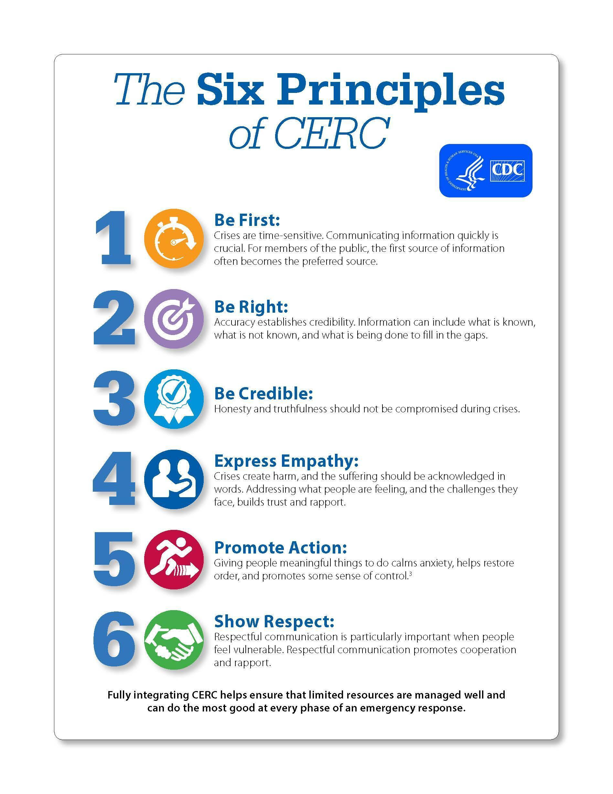

Appendix D: CMIST Functional Needs Framework
The CMIST Functional Needs Framework will inform the development and dissemination of public information. The framework includes five essential functions: communication, maintainin health, independence, support and safety, and transportation.
- Communication: Individuals who speak sign language, who have limited English proficiency (LEP), or who have limited ability to speak, see, hear, or understand
People with communication needs may have limited ability to hear announcements, see signs, understand messages, or verbalize their concerns.
- Maintaining Health: This category is about ensuring continuity of health and medical-related needs, such as individuals who may require specific medications, supplies, services, durable medical equipment, electricity for life-maintaining equipment, breastfeeding and infant/childcare, or nutrition, etc.
- Independence: Individuals who function independently with assistance from mobility devices or assistive technology, vision and communication aids, services animals, etc.
Independence is the outcome of ensuring that a person’s access and functional needs are addressed as long as they are not separated from their devices, assistive technology, service animals, etc.
- Support and Safety: Some individuals may become separated from caregivers and need additional personal care assistance; experience higher levels of distress and need support for anxiety, psychological, or behavioral health needs; or require a trauma-informed approach or support for personal safety.
- Transportation: Individuals who lack access to personal transportation, are unable to drive due to decreased or impaired mobility that may come with age and/or disability, temporary conditions, injury, or legal restriction.

Appendix E: Call Center Considerations
In an event that may involve significant public inquiry or information requests, [Name of Agency] may consider activating a disaster call center. A call center may also be activated in support of a Family Reunification Center and/or Disaster Assistance Center.
Goals for a call center may include:
- Provide accurate and timely information to residents, victims, and/or the family and friends of victims during and after a disaster.
- Connect interested parties with services ranging from information and education, connection to community resources, health promotion, reunification, and/or implementation of interventions to safeguard public health and safety.
- Direct media, volunteers, and other non-family and friends of victims to appropriate individuals to manager question responses.
- Collect important data for public health response and recovery operations.
Planning Considerations:
- Location
- Staffing; use of volunteers (e.g., Medical Reserve Corps)
- Equipment
  - Phones
  - Headsets
  - Computers
  - Database/form or other workflow to document calls
- Training (likely just-in-time)
  - Event-based information, scripts, FAQs
  - Equipment
- Scripts, talking points, frequently asked questions – including the ability to update regularly with changing situation and maintain version control
- Translation services
- Health Insurance Portability and Accountability Act (HIPAA) and protected health information
- Promoting numbers, websites, in connection with PIO
- Recorded messages on hotlines to reduce burden on call center

Appendix F: Inquiry Tracking
The following table may be used to track inquiries through resolution.
Date/Time | Name/Organization | Contact Information | Inquiry | Response

Appendix G: Public Information Officer Checklist
Mission: Serve as the conduit for information to internal and external stakeholders, including staff, residents, businesses, and the news media, as approved by the Incident Commander.
Immediate (0-2 hours) | Time/Notes
Receive appointment
- Obtain briefing from the Incident Commander on:
  - Size and complexity of incident
  - Expectations of the Incident Commander
  - Incident objectives
  - Involvement of outside agencies, stakeholders, and organizations
  - The situation, incident activities, and any special concerns
- Assume the role of Public Information Officer (PIO)
- Review this Job Action Sheet
- Put on position identification (e.g., position vest)
- Notify your usual supervisor of your assignment
- Arrange for necessary work space, materials, telephones, and staff
Assess the operational situation
- Attend all briefings and Incident Action Plan (IAP) meetings to gather and share incident information
- Assess need for immediate alert and warning messaging
- Establish contact with local or other media outlets to access and assess current situation
- Provide media, internal, and external messaging information to EOC and/or agency staff as appropriate
Determine public information incident objectives, tactics, and assignments
- Develop response strategy and tactics and outline an action plan
- Designate times for briefings to media, personnel, stakeholders/response partners, and the public
Activities
- Brief public information team members, if assigned, on current situation, incident objectives, and their assignments
- Establish a designated media staging and media briefing area located away from the incident scene and EOC
- Inform on site media of the physical areas to which they have access and those that are restricted
- Contact external Public Information Officers (PIOs) from partner agencies to ascertain and collaborate on public information and media messages being developed by those entities and ensure consistent and collaborative messages from all entities
- In collaboration with the Incident Commander, consider assigning a public relations staff member to the Joint Information Center (JIC), if activated
- Monitor, or assign personnel to monitor and report to you, incident and response information from sources such as the internet, radio, television, and newspapers
- Develop public information and media messages to be reviewed and approved by the Incident Commander before release to the news media and the public
- Document all key activities, actions, and decisions in an Operational Log (ICS Form 214) on a continual basis.
- Request resources and/or activation of agreements (e.g., for translation) in coordination with Logistics and/or Finance.
Message Development
- Address any health, medical, and safety concerns
- Work with subject matter expert(s) to develop tailored incident-specific information
- Address political sensitivities, when appropriate
- Identify any at-risk or disproportionately impacted populations, including access and/or functional needs, and strategies to reach the whole community
- Identify method(s) to disseminate messages, including print, electronic, news media, websites, social media, etc.
Safety and Security
- Coordinate designation of media staging and briefing area with the Operations Section Security Branch Director
- Ensure that any assigned personnel comply with safety procedures and instructions including the use of personal protective equipment (PPE) as warranted

Ongoing Response (2+ hours) | Time/Notes
Activities
- Continue to attend all briefings and Incident Action Plan (IAP) meetings to gather and share incident and organizational information
- Contribute media and public information activities and goals to the IAP
- Continue to receive regular progress reports from the Incident Commander, Section Chiefs, and others, as appropriate
- Activate social media outlets for dissemination of response information
- Determine whether a local, regional, or state Joint Information Center (JIC) is activated; provide support as needed; and coordinate information dissemination
- Continue to develop and revise public information and media messages to be reviewed and approved by the Incident Commander before release to the news media and the public
- Develop regular information and status update messages to keep personnel informed
- Ensure your physical readiness through proper nutrition, water intake, rest, and stress management techniques
- Ensure that any assigned personnel comply with safety procedures and instructions including the use of personal protective equipment (PPE) as warranted
- Transfer the Public Information Officer (PIO) role, if appropriate
  - Conduct a transition meeting to brief your replacement on the current situation, response actions, available resources, and forecasted events
  - Address any health, medical, and safety concerns
  - Address political sensitivities, when appropriate
  - Instruct your replacement to complete the appropriate documentation and ensure that appropriate personnel are properly briefed on response issues and objectives

Demobilization/Recovery | Time/Notes
Activities
- Return staff to their normal jobs and combine or deactivate positions in a phased manner
- Ensure the return or retrieval of equipment and supplies and return all assigned incident command equipment
- Brief the Incident Commander on current problems, outstanding issues, and follow up requirements
- Submit comments to the Planning Section Chief for discussion and possible inclusion in an After Action Report and Corrective Action and Improvement Plan. Topics include:
  - Review of pertinent position activities and operational checklists
  - Recommendations for procedure changes
  - Accomplishments and issues
- Participate in stress management and after action debriefings
- Participate in other briefings and meetings as required
- Coordinate the release of final media briefings and reports

Appendix H: Sample Message Guidance
Timely communication is critical during an emergency event. CERC emphasizes the urgency of crisis communication, recognizing that decisions about risks and behaviors must be made within a narrow timeframe. The decision may need to be made with imperfect or incomplete information. Sometimes it may be advantageous to recognize an event has occurred and that more information will be forthcoming.
Good communication enables organizations to fulfill their mission, maintain public trust, manage limited resources, and most of all, prevent and reduce illnesses and injuries. Throughout every step of an effective response, be first, be right, be credible, express empathy, promote action, and show respect.
Prepare initial information summary as soon as possible after activation. If no other information is available, consider the use of the following general statement:
We are aware that an [accident/incident] involving [type of incident] occurred at approximately [time], in the vicinity of [general location]. [Agency personnel] are responding, and we will have additional information available as we are able to confirm it. We will hold a briefing at [location], and will notify the press at least ½ hour prior to the briefing. At this time, this briefing is the only place where officials authorized to speak about the incident and confirmed information will be available. Thank you for your assistance.
You may also consider setting up a pre-recorded message on the general phone line, a website banner for incident specific information, and/or social media content.
Communities may consider drafting emergency message templates based on top hazards and risks identified.
The following tools may also be used to help develop messages. Additional content may be accessed in the Johns Hopkins Center for Health Security “Practical Playbook for Addressing Health Rumors.”

Message Framing Strategies and Templates
Technique | Description | Example
Moral reframing* | When the message is intended to present information that an individual would not normally support in a way that is consistent with their moral values.2 | Wearing a mask is a simple way to keep disease from spreading, which can reduce government interference and increase freedom of movement.
Argument framing | Mention the consequences of an action using conditional “if-then” arguments. This is a familiar way of trying to convince people to follow a course of action. | If you wash your hands after playing with your pet turtle, then you can keep yourself safe from the salmonella outbreak that is going around.
Antecedent variation | Flip the action to either emphasize what people gain or lose from doing or not doing an action. The focus is on the action. | People who don’t verify whether a rumor is true will be more likely to fall victim to fake news vs. People who verify whether a rumor is true will be more likely to share accurate news.
Consequent variation | Flip the consequence or outcome to emphasize whether people gain or lose from an action. The focus is on the consequences. | People who verify if a rumor is true will be less likely to share fake news.
Short-term consequences | Focus on outcomes and consequences that manifest immediately. | Vaccines can reduce a person’s chances of getting sick.
Long-term consequences | Focus on outcomes and consequences that manifest after some time has passed. | Vaccines can improve herd immunity for our whole community.
Self-oriented consequences* | Focus on consequences for the message recipient. | Vaccines can reduce your chances of getting sick.
Other-oriented consequences | Focus on consequences that happen to other people. | Vaccines can reduce infection risk for immunocompromised people.
Prevention-oriented consequences* | Focus on preventing a negative outcome (prioritizes security). | Keep checking CDC’s website to avoid falling for incorrect news about heatwaves from unofficial sources.
Promotion-oriented consequences* | Focus on improving a positive outcome (prioritizes growth). | Keep checking CDC’s website to stay up to date with the latest developments.
Health consequences* | Appeal to consequences related to people’s health. | Avoid going home to flood-affected areas to reduce your risk of getting infected by contaminated floodwater.
Non-health consequences | Appeal to consequences related to non-health outcomes that people care about. | Avoid going home to flood-affected areas because you might lose control of your vehicle while driving and cause further damage.
Attribute framing | Advertise strategic features or attributes of an option to sway a person’s decision. | Around 23% of people at risk for mpox got vaccinated vs. Around 77% of people at risk are not protected against mpox.
Outcome likelihood framing | Describe a behavior as leading to a certain likelihood of the outcome happening. | Like other routine vaccines, side effects of the updated COVID-19 vaccine are usually mild and go away after a few days.
Risky choice framing | Present the subject with options that force a choice, usually between losing or gaining an outcome. | Potential side effects of vaccinating against COVID-19 are aches, chills, and fever. Potential side effects of getting COVID-19 are hospitalization or death.
Metaphor framing | Make a complex topic easier for audiences to understand by evoking characteristics of another simpler, symbolic concept. | Use a row of matches with a gap separating lit matches from unlit matches as a visual aid to depict the value of physical distancing.

You can frame messages using the following CDC CERC guidance.
CERC Considerations | Application
Present a concise message | Avoid jargon, keep it simple, only include relevant information
Repeat the main message | Frequently heard messages can help with retention when uncertainty is high
Give action steps in positives (when feasible) | Tell people what to do, more than what not to do
Create action steps in sets of 3 or 4 | Short lists are easier to remember
Use personal pronouns | Humanize the message with I/we statements
Respect people’s fears and perceptions | Recognize emotions, avoid judgement and condescension
Give people options | Avoid paternalistic ways to inform decision-making
Avoid humor | Remember to be sensitive to people’s emotions
The following worksheet can be used to develop messages using CERC framing.
Guiding Questions | Agency Responses
What is your core message?
How will you repeat your main message?
What are your action steps?
How will you respect people’s fears and perceptions?
What options are you giving your audience?
The following worksheet can be used to develop messages using debunking framing.
Guiding Questions | Agency Responses
What is your fact? State what is true first.
How will you warn about the myth? Repeat the rumor, only once, directly prior to the correction.
How will you explain the fallacy? Ensure the rebuttal is clearly and saliently paired with the rumor.
What fact are you reinforcing at the end? Restate the fact again, so the fact is the last thing people process.

Truth Sandwich Technique
The “Truth Sandwich” is a journalism technique that is similar to approaches used in debunking but focuses more on preventing the unintentional spread of additional false or misleading claims. The basic structure of a Truth Sandwich is:
- Start with the truth. The first frame gets the advantage.
- Indicate the lie. Avoid amplifying the specific incorrect language if possible.
- Return to the truth. Always repeat truths more than lies.

For example, the following Truth Sandwich script might be used during a natural disaster to address a rumor that individuals cannot use a disaster shelter unless they are US citizens:
Truth | We understand that there are concerns about shelter availability. We want to emphasize that any member of the public can use a disaster shelter.
Lie | No one will be turned away from a disaster shelter based on citizenship.
Truth | Disaster shelters are open to all members of the public.

Guiding Questions | Agency Responses
What is the first truth you want to share?
How will you indicate the lie?
How will you repeat your truth statement?

Worksheet for Developing Messages to Counter Rumors
You can use the worksheet to respond to a range of rumors that come up during emerging public health issues.
Guiding question | Your answer | Notes
What is the rumor? |  | Use approaches in the Set up a way to identify rumors section to understand the rumor you have detected and its level of risk.
What type of rumor is it? State why it is a rumor and what information would discount or address it.
What level of risk does this rumor pose? |  | If the level of risk is HIGH, you may need to “pre-bunk” or inoculate people against the rumor as soon as you detect it.
Who is spreading the rumor?
Does the rumor disproportionately affect any populations? Explain |  | If YES to either, prioritize these respective populations before others.  If NO or unclear to both, prioritize other groups as discussed below.
Are some people more inclined to believing this rumor? Explain
Would a message from your organization or partner organization(s) stop people who spread this rumor from doing so? Explain |  | If YES to all, add general audiences and partner organizations, then people who are spreading the rumor to the priority list.  If NO to any, prioritize general audiences.
Does the community perceive your organization to be a trusted messenger? Explain
Do you work with any partner organizations that are trusted messengers for people spreading the rumor? |  | If YES, co-create tailored messages intended for priority audiences with them and disseminate through their channels, in addition to your own efforts.  If NO, focus on people who are likely to believe and be most impacted by the rumor, as well as general audiences.
Who are the priority audiences for your message?
What additional information do you need to consider about these audiences when creating messages? |  | Consider factors like audiences’ priorities, values, questions, concerns, needs, beliefs etc.
What are your communication goals? List them in an order that aligns with your priority audiences.
Which action approach(es) will you use? List them by audience. |  | If you responded HIGH RISK to Q3, prioritize prebunking and inoculation.
On which platform(s) is this rumor spreading?
Which communications channels will you prioritize for disseminating your message? |  | Prioritize based on Q14 but add others, like partners’ preferred platforms. The format, character limits, structure, and framing of the message you develop in Q23 will depend on the communications channel you choose.
Which organizations, businesses, online or community influencers do priority audiences trust? List them in order of preference by audiences. |  | Co-create messages with these parties and include them as disseminators.
List the trusted sources and partners that will serve as messengers.
List other considerations that inform your message dissemination strategy.
Are your priority audiences’ motivations to change behaviors and beliefs driven by specific benefits or moral values? |  | If YES, use gain framing or moral reframing techniques for your message.  If NO, use other message framing strategies.
List any message framing strategies you will incorporate into your message and why. |  | Consider the motivations of your priority audiences. Use resources from Appendix D: Message Framing Strategies and Templates.
List any message framing templates you might use to create your message.
How will you tailor your message to match your priority audiences? |  | Remember to tailor based on your answers to Q15-18.
Share the message(s) you have created. State the target audience(s) and dissemination channel(s) for each. |  | Adapt based on your communications channels from Q15 and message framing techniques from Q19-22.
Did you incorporate good practices related to language, tone, visuals, structure, etc.? |  | If YES, proceed to dissemination.  If NO, incorporate good practices for quality assurance or accept consequences of not doing so.
What are some underlying assumptions of your message?
What are some potential pitfalls of your message and how will you address them (if at all)?

Appendix I: Template Instructions
The Region 4AB Public Health Emergency Preparedness Coalition has developed a template for local jurisdictions to create a customized Crisis and Emergency Risk Communication Plan. This document meets the requirements set forth by the Massachusetts Department of Public Health.
This template is only a suggestion and can be reformatted; you may add/change/delete content or use provided content to enhance any existing plans you may already have. In general, any sections or content that is not relevant to your organization/jurisdiction can be updated or deleted.
Note: this plan is only a template and must be reviewed and edited
with content specific to your organization/jurisdiction before finalizing.
Overarching Document Guidance:
- It is suggested that you do not develop this plan “in a bubble” – engage key stakeholders to provide information and feedback, especially any identified public information officers and/or spokespersons from your agency. Consider also speaking with your jurisdiction’s Emergency Management point of contact.
- Identify if this plan will be freestanding or an annex to the All-Hazards Public Health Emergency Response Framework or comparable plan.
- Any text that is highlighted yellow should be reviewed and organization/jurisdiction names and/or information should be added here. Remove highlight once information is customized.
- Delete any content that is not applicable to your jurisdiction. Add any additional information you think is important.
- After making final edits, we suggest running spellcheck on the document.
- After making final edits, we suggest right-clicking each table of contents and selecting “update table” to ensure page numbers and section headers are updated.
- Once all final edits are completed, document the date and edits in the Record of Changes. It is also suggested that you provide this plan to internal stakeholders for final review prior to approval.
- You may delete this Appendix H: Template Instructions after customizing the document.

https://www.cdc.gov/healthcommunication/Health_Equity_Lens.html
https://thinkculturalhealth.hhs.gov/clas
Disproportionately impacted populations refers to when a subset of the population, based on characteristics, such as age, race and gender, are unjustifiably experiencing lower outcomes compared to the total population.
National Standards for Culturally and Linguistically Appropriate Services https://thinkculturalhealth.hhs.gov/clas
https://www.section508.gov/
Managing_ Rumours_SIDA_SRH_HIV_COVID-19_Intervention.pdf
Practical Playbook for Addressing Health Rumors

